Agenda:
- Introduction to Kafka
- Kafka terminology
- Kafka Setup
- Kafka Producers
- Kafka Consumers
- Kafka Internals
- Reliable data delivery
- Stream processing in Kafka

Break Timings:
- First break around 11:30 AM IST - 15 mins
- Second break around 01:00 PM IST - 45 + 15 mins
- Third break around 03:30 PM IST - 15 mins

Introduction to Kafka
Types of message exchange:
- Synchronous → Immediate response
- Asynchronous
  - One way (fire and forget)
  - Two way (delayed response)

Asynchronous Messaging:
- Point to Point → One message for One Receiver
- Publish Subscribe → One message for multiple Subscribers

Question: I need to broadcast a message. Which Async messaging should I go for?
Answer: Publish Subscribe

Asynchronous Messaging (Infrastructure):
- Point to Point ⇒ Message Queues
- Publish Subscribe ⇒ Message Topics

Producer sent a message to Queue, Consumer is not alive (program is not running)
=> Message is safely preserved in Queue until Consumer comes alive.
Publisher sent a message to Topic, Subscriber is not alive (program is not running).
=> Message is deleted from Topic saying No Subscribers are active.

Apache Kafka Solution
Publish Subscribe Solution

Kafka Setup
Softwares required:
- Zookeeper ⇒ Key value database to store the configuration information
- Kafka

Practice 1 - Setup Single Kafka Broker using inbuilt ZooKeeper instance
- Download kafka from https://archive.apache.org/dist/kafka/2.5.0/kafka_2.12-2.5.0.tgz
- Unzip kafka to C:\kafka using 7-zip (first unzip tgz to create tar file, then extra TAR file to get the folder)
- Kafka uses ZooKeeper so you need to first start a ZooKeeper server if you don't already have one.
You can use the convenience script packaged with kafka to get a quick-and-dirty single-node ZooKeeper instance.
  - Start Command Prompt and execute below commands
cd C:\kafka\kafka_2.12-2.5.0
bin\windows\zookeeper-server-start.bat config\zookeeper.properties
- Now start the Kafka server
  - Start a command prompt and execute below commands
cd C:\kafka\kafka_2.12-2.5.0
bin\windows\kafka-server-start.bat config\server.properties
- Create a topic by name ‘test’
  - Start Command Prompt and execute below commands
cd C:\kafka\kafka_2.12-2.5.0
bin\windows\kafka-topics.bat --create --bootstrap-server localhost:9092 --replication-factor 1 --partitions 1 --topic test
- List the created topics using below command
bin\windows\kafka-topics.bat --list --bootstrap-server localhost:9092

Start the Consumer (CLI)
- Start a consumer
bin\windows\kafka-console-consumer.bat --bootstrap-server localhost:9092 --topic test

Start the Producer (CLI)
- Start a new command prompt
- Send some messages
bin\windows\kafka-console-producer.bat --bootstrap-server localhost:9092 --topic test
Wait for the ">" prompt
- Type some message and press Enter

Verify the Messages being consumed
- Change focus to producer command prompt, and type a message then press enter key.
- Notice, the message appears on the consumer screen.

Do it yourself:
Try launching another consumer and send new messages

Terminology used in Kafka
- Message → A piece of Data, optionally identified by a Key. A message is published by Publisher and Consumed by Subscriber.
- Batch → Collection of multiple messages is a Batch, this is used to minimize the network usage.
- Schema (Optional) → Every message is associated with a Schema. E.g. Employee object has a Schema of Employee class. Dealing with understandable messages.
- Topic → Categories in Kafka for messages
- Producer → Code / Program generating the message and sending to Topic (Publisher)
- Consumer → Code / Program receiving message from the Topic (Subscriber)
- Kafka Broker → Single Kafka Server
- Kafka Cluster → Multiple Kafka Servers to address the scaling needs
- Consumer Group → Related to Scaling in Consumers (ensure that group.id is same for multiple consumers acting as one subscriber)
- Partition → Related to Scaling with Kafka Broker (Further categorization of Topics is Partition)
- Retention → For how long the processed Messages should saved in Kafka

Kafka Producers and Consumers

Practice 2 - Producer and Consumer

Practice 2.1 - Kafka Producers (Java API)
- Start the Kafka Broker and Zookeeper (if not running)
cd C:\kafka\kafka_2.12-2.5.0
bin\windows\zookeeper-server-start.bat config\zookeeper.properties
bin\windows\kafka-server-start.bat config\server.properties
- Create a folder ‘kafka’ within ‘C:\labs’ folder
- Create a folder ‘src’ within ‘C:\labs\kafka’
- Write a program for sending 5 messages to Kafka Topic named ‘test’
  - Create a new file named OneWayProducer.java within c:\labs\kafka\src folder
  - Update the OneWayProducer.java file with below code
import org.apache.kafka.clients.producer.ProducerRecord;
import org.apache.kafka.clients.producer.KafkaProducer;
import org.apache.kafka.clients.producer.Producer;
import java.util.Properties;

public class OneWayProducer{
public static void main(String args[]){
Properties props = new Properties();
props.put("bootstrap.servers", "localhost:9092");
props.put("key.serializer", "org.apache.kafka.common.serialization.StringSerializer");
props.put("value.serializer", "org.apache.kafka.common.serialization.StringSerializer");

Producer<String, String> producer = new KafkaProducer<>(props);

for (int i = 0; i < 5; i++){
ProducerRecord record = new ProducerRecord<String, String>("test", Integer.toString(i), "Value: " + Integer.toString(i)); //Number 'i' is key, and "Value: i" is message data
producer.send(record);
}
producer.close();
}
}
- Start a Consumer using CLI
> cd C:\kafka\kafka_2.12-2.5.0
> bin\windows\kafka-console-consumer.bat --bootstrap-server localhost:9092 --topic test --from-beginning
- Compile and execute the code
  - Start a new Command prompt and execute below commands
⇒ cd c:\labs\kafka\src
⇒ SET CLASSPATH=C:\kafka\kafka_2.12-2.5.0\libs\kafka-clients-2.5.0.jar;C:\kafka\kafka_2.12-2.5.0\libs\slf4j-api-1.7.30.jar;C:\kafka\kafka_2.12-2.5.0\libs\slf4j-log4j12-1.7.30.jar;C:\kafka\kafka_2.12-2.5.0\libs\log4j-1.2.17.jar;.;
⇒ javac *.java
⇒ java OneWayProducer
  - Verify the consumer console for the messages
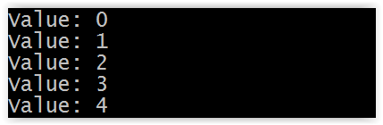
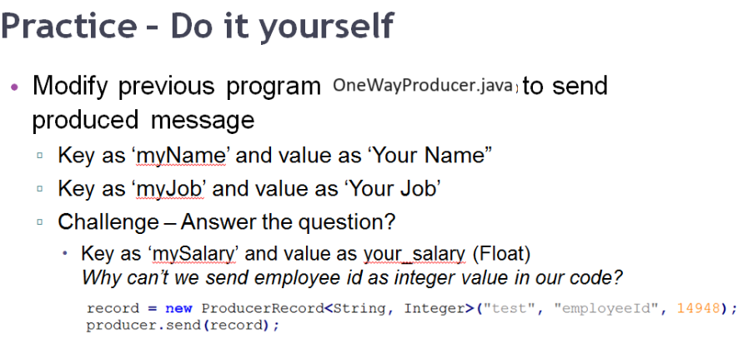

Practice 2.2 - Kafka Consumers (Java API)
- Start the Kafka Broker and Zookeeper
cd C:\kafka\kafka_2.12-2.5.0
bin\windows\zookeeper-server-start.bat config\zookeeper.properties
bin\windows\kafka-server-start.bat config\server.properties
- Write a program to consume messages from Kafka Topic named ‘test’ under the consumer group ‘test-group-0’
  - Create a new file named OneWayConsumer.java within c:\labs\kafka\src folder
  - Update the OneWayConsumer.java file with below code
import org.apache.kafka.clients.consumer.KafkaConsumer;
import org.apache.kafka.clients.consumer.ConsumerRecords;
import org.apache.kafka.clients.consumer.ConsumerRecord;
import java.util.Properties;
import java.util.Collections;

public class OneWayConsumer{
public static void main(String args[]){
Properties kafkaProps = new Properties();
kafkaProps.put("bootstrap.servers", "localhost:9092");
kafkaProps.put("group.id","consumer-group-id"); //Helps in creating a Consumer Group
kafkaProps.put("key.deserializer","org.apache.kafka.common.serialization.StringDeserializer");
kafkaProps.put("value.deserializer","org.apache.kafka.common.serialization.StringDeserializer");

KafkaConsumer<String, String> consumer = new KafkaConsumer<String,String>(kafkaProps);
consumer.subscribe(Collections.singletonList("test"));
try {
int i=0;
System.out.println("----------- Started Polling For Data ----------- ");
while (i < 2000) {
i++;
ConsumerRecords<String, String> records = consumer.poll(100);
for (ConsumerRecord<String, String> record : records){
System.out.printf("Partition = %d, offset = %d, key = %s, value = %s%n",
record.partition(), record.offset(), record.key(), record.value());
}
}
System.out.println("----------- Completed Polling ----------- ");
consumer.close();
} catch (Exception e) {
e.printStackTrace();
}
}
}
- Compile and execute the code
  - Start a new Command prompt and execute below commands
⇒ cd c:\labs\kafka\src
⇒ SET CLASSPATH=C:\kafka\kafka_2.12-2.5.0\libs\kafka-clients-2.5.0.jar;C:\kafka\kafka_2.12-2.5.0\libs\slf4j-api-1.7.30.jar;C:\kafka\kafka_2.12-2.5.0\libs\slf4j-log4j12-1.7.30.jar;C:\kafka\kafka_2.12-2.5.0\libs\log4j-1.2.17.jar;.;
⇒ javac *.java
⇒ java OneWayConsumer
  - Start a new command prompt and execute below commands to send messages
⇒ cd c:\labs\kafka\src
⇒ SET CLASSPATH=C:\kafka\kafka_2.12-2.5.0\libs\kafka-clients-2.5.0.jar;C:\kafka\kafka_2.12-2.5.0\libs\slf4j-api-1.7.30.jar;C:\kafka\kafka_2.12-2.5.0\libs\slf4j-log4j12-1.7.30.jar;C:\kafka\kafka_2.12-2.5.0\libs\log4j-1.2.17.jar;.;
⇒ javac *.java
⇒ java OneWayProducer
  - Verify from the Consumer command prompt that messages are displayed.
- Close the command prompts

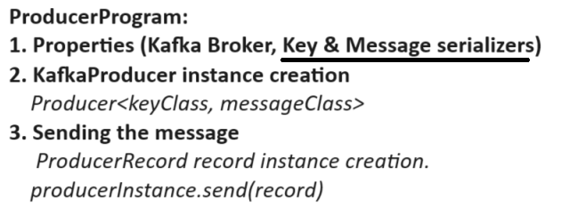 | 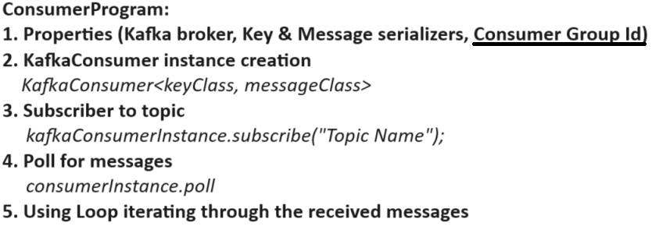

Serialization and Deserialization

Practice 3 - Serialization and Deserialization
- Create Customer.java (Domain Object representing JSON data)
package com.example.training;

public class Customer {
private String id;
private String name;

public String getId(){
return this.id;
}
public void setId(String id){
this.id = id;
}

public String getName(){
return this.name;
}
public void setName(String name){
this.name = name;
}
}
- Create CustomerSerializer.java (code to generate json data → generate byte array)
package com.example.training;

import org.apache.kafka.common.serialization.Serializer;
import org.apache.kafka.common.errors.SerializationException;
import com.fasterxml.jackson.databind.ObjectMapper;
import java.util.*;

public class CustomerSerializer implements Serializer<Customer> {
private final ObjectMapper objectMapper = new ObjectMapper();

@Override
public void configure(Map<String, ?> configs, boolean isKey) {
}

@Override
public byte[] serialize(String topic, Customer data) {
try {
if (data == null){
System.out.println("Null received at serializing");
return null;
}
System.out.println("Serializing...");
return objectMapper.writeValueAsBytes(data);
} catch (Exception e) {
throw new SerializationException("Error when serializing Customer to byte[]");
}
}

@Override
public void close() {
}
}

- Create CustomerDeserializer.java (code to generate object from JSON data’s byte array)
package com.example.training;

import org.apache.kafka.common.serialization.Deserializer;
import org.apache.kafka.common.errors.SerializationException;
import com.fasterxml.jackson.databind.ObjectMapper;
import java.util.*;

public class CustomerDeserializer implements Deserializer<Customer> {
private ObjectMapper objectMapper = new ObjectMapper();

@Override
public void configure(Map<String, ?> configs, boolean isKey) {
}

@Override
public Customer deserialize(String topic, byte[] data) {
try {
if (data == null){
System.out.println("Null received at deserializing");
return null;
}
System.out.println("Deserializing...");
return objectMapper.readValue(data, Customer.class);
} catch (Exception e) {
throw new SerializationException("Error when deserializing byte[] to Customer");
}
}

@Override
public void close() {
}
}
- Create the Producer code
package com.example.training;

import org.apache.kafka.clients.producer.ProducerRecord;
import org.apache.kafka.clients.producer.KafkaProducer;
import org.apache.kafka.clients.producer.Producer;
import java.util.Properties;

public class OneWayProducer{
public static void main(String args[]) throws Exception{
Properties props = new Properties();
props.put("bootstrap.servers", "localhost:9092");
props.put("key.serializer", "org.apache.kafka.common.serialization.StringSerializer");
props.put("value.serializer", "com.example.training.CustomerSerializer");
Producer<String,Customer> producer = new KafkaProducer<>(props);
Customer james = new Customer();
james.setId("C001");
james.setName("James Cooper");
ProducerRecord record = new ProducerRecord<String, Customer>("CRM", 0, "HYD", james);
producer.send(record);
producer.close();
}
}

- Create the Consumer code
package com.example.training;

import org.apache.kafka.clients.consumer.KafkaConsumer;
import org.apache.kafka.clients.consumer.ConsumerRecords;
import org.apache.kafka.clients.consumer.ConsumerRecord;
import org.apache.kafka.common.TopicPartition;
import org.apache.kafka.clients.consumer.OffsetAndMetadata;
import java.util.Properties;
import java.util.Collections;

public class OneWayConsumer{
public static void main(String args[]){
Properties kafkaProps = new Properties();
kafkaProps.put("bootstrap.servers", "localhost:9092");
kafkaProps.put("group.id","invalid");
kafkaProps.put("enable.auto.commit","true");
kafkaProps.put("key.deserializer","org.apache.kafka.common.serialization.StringDeserializer");
kafkaProps.put("value.deserializer","com.example.training.CustomerDeserializer");

KafkaConsumer<String, Customer> consumer = new KafkaConsumer<String,Customer>(kafkaProps);
consumer.subscribe(Collections.singletonList("CRM"));
try {
int i=0;
System.out.println("----------- Started Polling For Data ----------- ");
while (i < 200) {
i++;
ConsumerRecords<String, Customer> records = consumer.poll(100);
for (ConsumerRecord<String, Customer> record : records){
Customer customer = record.value();
System.out.println("Customer Id: "+ customer.getId());
System.out.println("Customer Name: "+ customer.getName());
}
}
System.out.println("----------- Completed Polling ----------- ");
consumer.close();
} catch (Exception e) {
e.printStackTrace();
}
}
}
- Execute the program
  - Compiling the code
⇒ cd c:\labs\kafka\src
⇒ SET CLASSPATH=C:\kafka\kafka_2.12-2.5.0\libs\kafka-clients-2.5.0.jar;C:\kafka\kafka_2.12-2.5.0\libs\slf4j-api-1.7.30.jar;C:\kafka\kafka_2.12-2.5.0\libs\slf4j-log4j12-1.7.30.jar;C:\kafka\kafka_2.12-2.5.0\libs\log4j-1.2.17.jar;.;C:\kafka\kafka_2.12-2.5.0\libs\jackson-databind-2.10.2.jar;C:\kafka\kafka_2.12-2.5.0\libs\jackson-core-2.10.2.jar;C:\kafka\kafka_2.12-2.5.0\libs\jackson-annotations-2.10.2.jar;.;
⇒ javac -d . *.java
  - Executing the producer code
java com.example.training.OneWayProducer
  - Executing the consumer code
java com.example.training.OneWayConsumer

- Do it yourself: Introduce a CITY attribute within Customer.java and use it as KEY for message

Practice 4 - Kafka with Maven and Eclipse IDE
- Start the Kafka Server using below commands (please ignore, if Kafka & zookeeper are already running)
  - Start the Internal Zookeeper
    - Launch a new command prompt
    - Execute below commands
cd C:\kafka\kafka_2.12-2.5.0
bin\windows\zookeeper-server-start.bat config\zookeeper.properties
  - Start Kafka Server
    - Launch a new command prompt
    - Execute below commands
cd C:\kafka\kafka_2.12-2.5.0
bin\windows\kafka-server-start.bat config\server.properties
  - Create a new topic named ‘d2-test’
    - Launch a new command prompt
    - Execute below commands
> cd C:\kafka\kafka_2.12-2.5.0
> bin\windows\kafka-topics.bat --create --bootstrap-server localhost:9092 --replication-factor 1 --partitions 1 --topic d2-test
- Download and Install eclipse (please ignore if you already have an IDE)
  - Download the eclipse ZIP from https://drive.google.com/file/d/16od4yFBkrF4XYwuKdl5B__z7BzBFrhOs/view
  - Extract the download archive to C:\Oracle\Softwares folder
  - Double click on C:\Oracle\Softwares\eclipse\eclipse.exe file
  - Provide the workspace path as C:\labs\kafka → Click Launch
- Create a new Maven project (please disconnect from VPN)
  - Click on File → Click New → Click Maven Project
Note: if maven project is not visible, click Other and search for it
  - First Step: Click next
  - Second Step:
    - Search for ‘maven-archetype-quickstart’ using Filter text box
    - Select the ‘maven-archetype-quickstart’ of ‘1.4’ version → Click Next
  - Third Step:
    - Provide the group id as ‘com.example.training’
    - Provide the artifact id as ‘kafka-producer’
    - Uncheck ‘run archetype generation interactively’
    - Click Finish

- Update JDK version in pom.xml file
  - Double click on pom.xml file to open it
  - Update pom.xml file to change JDK version from 1.7 to 1.8
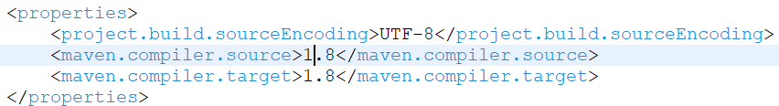
- Provide the kafka library dependency details
  - Update pom.xml file to add libraries slf4j, kafka-clients
<dependency>
<groupId>org.slf4j</groupId>
<artifactId>slf4j-simple</artifactId>
<version>1.7.32</version>
</dependency>
<dependency>
<groupId>org.slf4j</groupId>
<artifactId>slf4j-api</artifactId>
<version>1.7.32</version>
</dependency>
<dependency>
<groupId>org.apache.kafka</groupId>
<artifactId>kafka-clients</artifactId>
<version>3.0.0</version>
</dependency>
  - The updated file looks as below
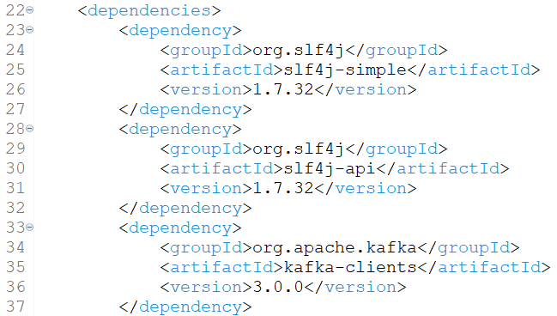
  - Save the changes done to pom.xml file
  - Verify if ‘kafka’ library is visible under ‘Maven Dependencies’
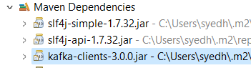
- Provide the provider api implementation
  - Create a new class called ‘OneWayProducer.java’
    - Right click on ‘kafka-producer’ project → Click New → Click Class
    - Provide the name as ‘OneWayProducer’ → Click Finish
  - Update OneWayProducer.java to use below code
package com.example.training.kafka_producer;

import org.apache.kafka.clients.producer.ProducerRecord;
import org.apache.kafka.clients.producer.KafkaProducer;
import org.apache.kafka.clients.producer.Producer;
import java.util.Properties;

public class OneWayProducer{
public static void main(String args[]){
Properties props = new Properties();
props.put("bootstrap.servers", "localhost:9092");
props.put("key.serializer", "org.apache.kafka.common.serialization.StringSerializer");
props.put("value.serializer", "org.apache.kafka.common.serialization.StringSerializer");

Producer<String, String> producer = new KafkaProducer<>(props);

for (int i = 0; i < 5; i++){
ProducerRecord record = new ProducerRecord<String, String>("d2-test", Integer.toString(i), "Value: " + Integer.toString(i));
producer.send(record);
}
System.out.println("5 Messages sent to Kafka topic d2-test");
producer.close();
}
}
  - Save the changes done to code
- Executing Producer code
  - Right click on OneWayProducer.java → Click Run As → Click Java Application
- DIY: Create another Maven project named ‘kafka-consumer’ with below code
package com.example.training.kafka_consumer;

import org.apache.kafka.clients.consumer.KafkaConsumer;
import org.apache.kafka.clients.consumer.ConsumerRecords;
import org.apache.kafka.clients.consumer.ConsumerRecord;
import java.util.Properties;
import java.util.Collections;

public class OneWayConsumer{
public static void main(String args[]){
Properties kafkaProps = new Properties();
kafkaProps.put("bootstrap.servers", "localhost:9092");
kafkaProps.put("group.id","consumer-group-id");
kafkaProps.put("key.deserializer","org.apache.kafka.common.serialization.StringDeserializer");
kafkaProps.put("value.deserializer","org.apache.kafka.common.serialization.StringDeserializer");
KafkaConsumer<String, String> consumer = new KafkaConsumer<String,String>(kafkaProps);
consumer.subscribe(Collections.singletonList("d2-test"));
try {
int i=0;
System.out.println("----------- Started Polling For Data ----------- ");
while (i < 2000) {
i++;
ConsumerRecords<String, String> records = consumer.poll(100);
for(ConsumerRecord<String, String> record : records){
System.out.printf("Partition = %d, offset = %d, key = %s, value = %s%n",
record.partition(), record.offset(), record.key(), record.value());
}
}
System.out.println("----------- Completed Polling ----------- ");
consumer.close();
} catch (Exception e) {
e.printStackTrace();
}
}
}

Let us conclude our discussion for today
Email: syed.hussaini@live.com

